Advance Programming
Pre Lecture
What is Programming?
Programming means writing step-by-step instructions (using a programming language like Java, C#, or JavaScript) to tell a computer what to do — such as calculating numbers, displaying websites, or managing data.
Visual Programming Vs Normal Programming
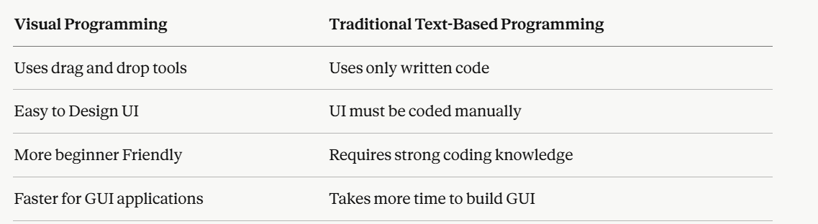
Programming vs Daily Life Language
Daily Life (Natural Language)
In natural language, semantics (meaning) matters more than strict rules.
Example:
- "Bring me water."
- "Can you bring water?"
- "Water, please."
All sentences are different in structure, but the meaning is understood.
Even if grammar is slightly wrong:
- "You bring water."
Computer Language (Programming)
- In programming, syntax (rules and structure) matters strictly.
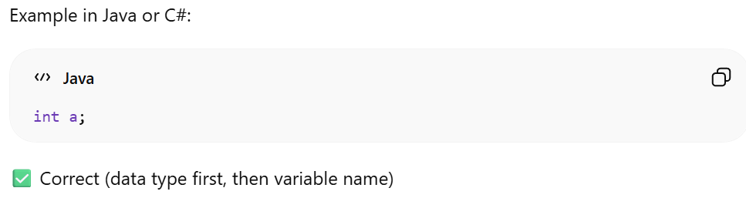
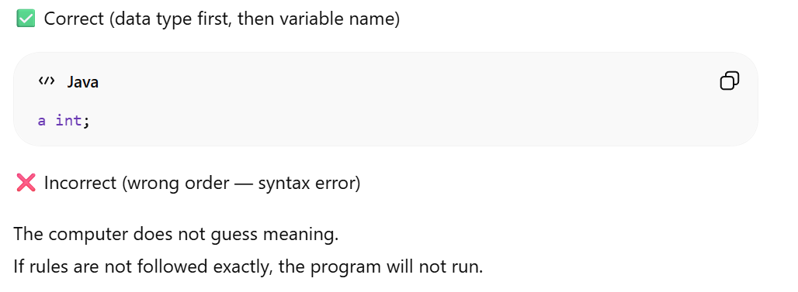
Event Driven Vs Procedural Programming
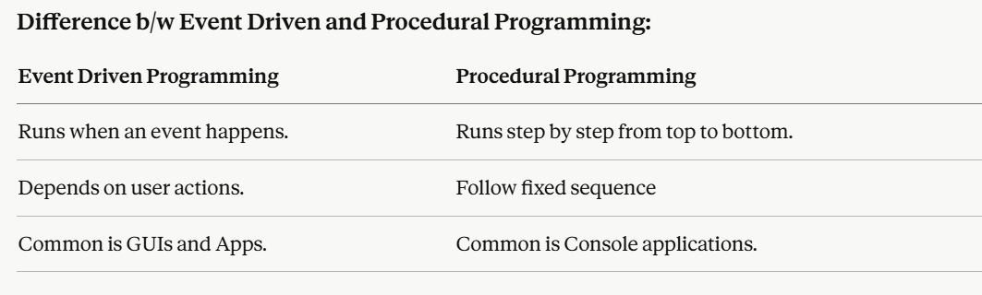

Step to convert high level language to machine language
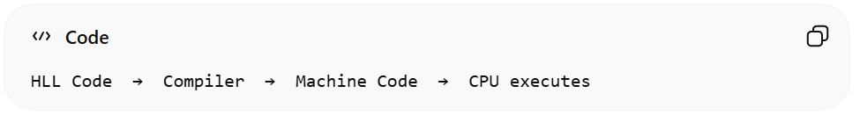
- HLL: Human-friendly language
- Machine Language: Computer-friendly language
- Compiler: Converts HLL into Machine Language
Integrated Development Environment
An IDE is a software tool that helps us write, run, and debug programs easily — all in one place.
Example
- Visual Studio (for C#)
- VS Code
Important flow diagram
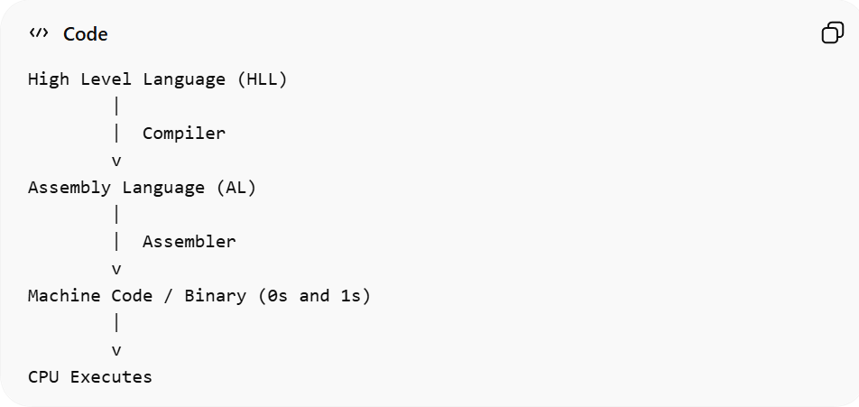

Program Execution Steps
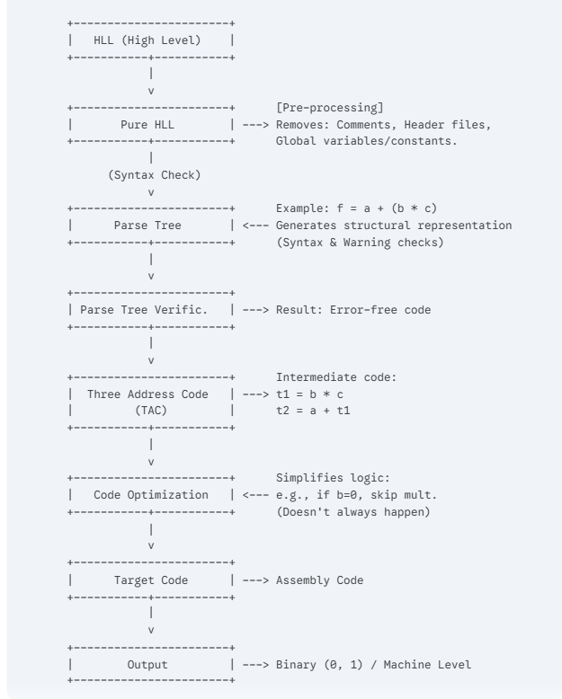
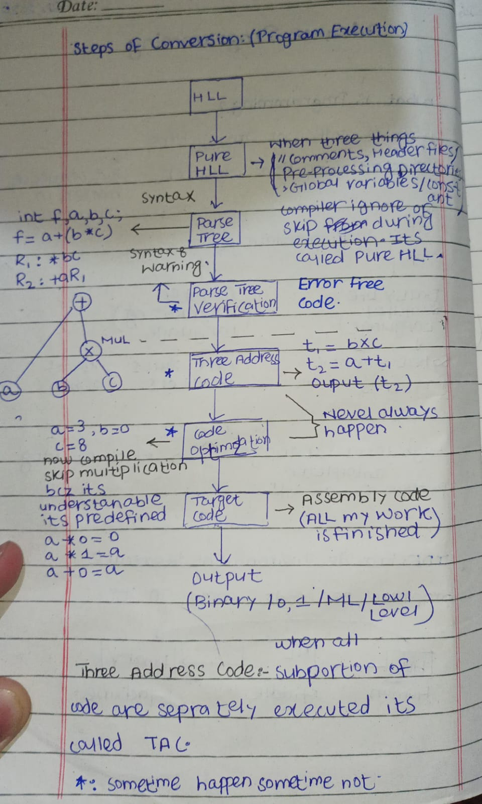
Detail Explanation of Figure
1. HLL to Pure HLL (Pre-processing)
Pure HLL is the form of High-Level Language code after pre-processing, in which the compiler skips comments, header files, pre-processing directories, and unnecessary information (like macros, etc.), leaving only the actual program instructions for compilation.
2. Parse Tree (Syntax Analysis)
The compiler checks whether your code follows the rules of the programming language. It creates a tree-like structure that shows how the code is organized. For example, in an expression like a + (b * c), the tree helps the compiler understand the order of operations. If there is a mistake (like missing a semicolon or wrong variable usage), the compiler shows syntax or warning errors at this stage.
3. Three Address Code (TAC)
This is an intermediate step. High-level instructions are broken down into simpler instructions that have at most three addresses (two operands and one result). Or when all the sub-portion of code is executed separately it’s called tac.
- Your Example: t1 = b * c and t2 = a + t1. Output = t2
- This makes it easier for the compiler to reorganize and optimize the logic.
4. Code Optimization
This is an optional but crucial step. The compiler looks for ways to make the code faster or smaller.
- Constant Folding/Simplification: As your note says, if b = 0, the compiler knows b * c is always 0, so it might skip the multiplication entirely to save processing power.
5. Target Code (Assembly): All our work is finished
The optimized code is converted into assembly language, which is a low-level language understood by the CPU. At this stage, high-level instructions are replaced with simple commands using registers and move operations.
6. Target Code (Assembly)
The final machine level code.
Some key Terms
- Code
Code is the instructions written in a programming language. It may include error or it can be error free. Output: (Yes, No)
- Program
A program is a set of instructions that performs a task. It is complete working code. Output: must but Front-end: (Yes, No)
- Software
Software is a complete package of programs that helps users do tasks. It has been executed and run on many machines. Output: must and Front-end: must
- Application
An application is software made for users to perform specific tasks. It may be available online or can be on desktop, web and mobile.
- Implementation
Error free code integrated with front-end.

- Development
Development is the whole process of creating software or application.
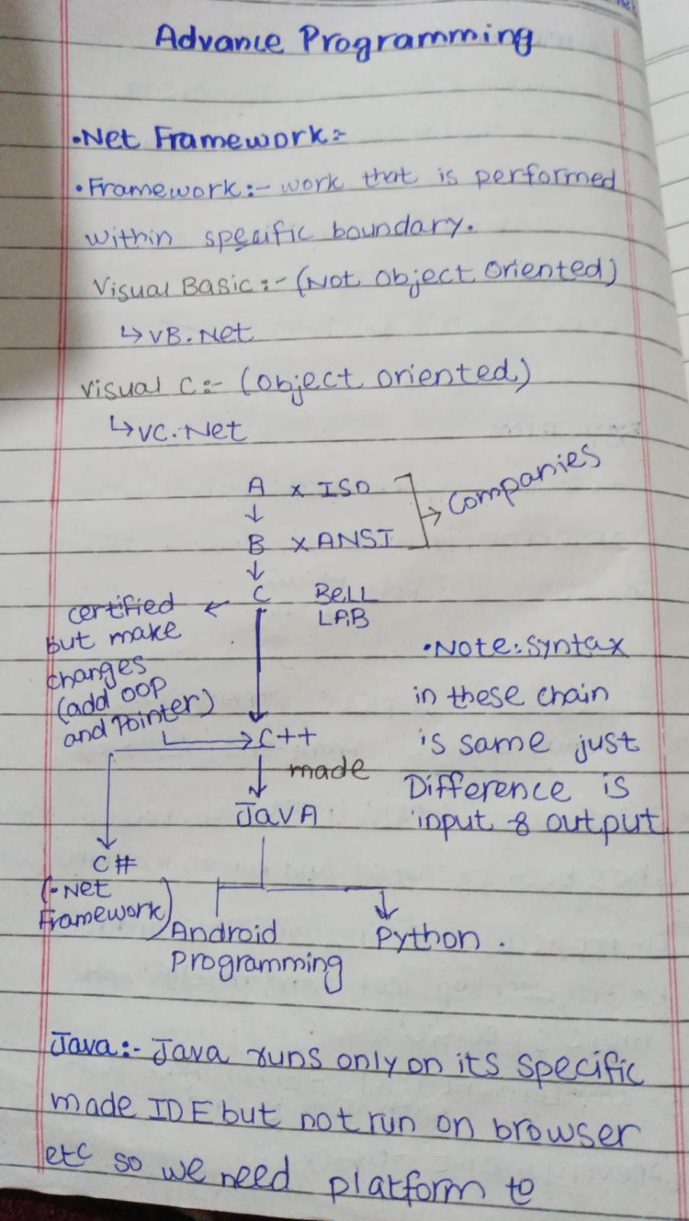
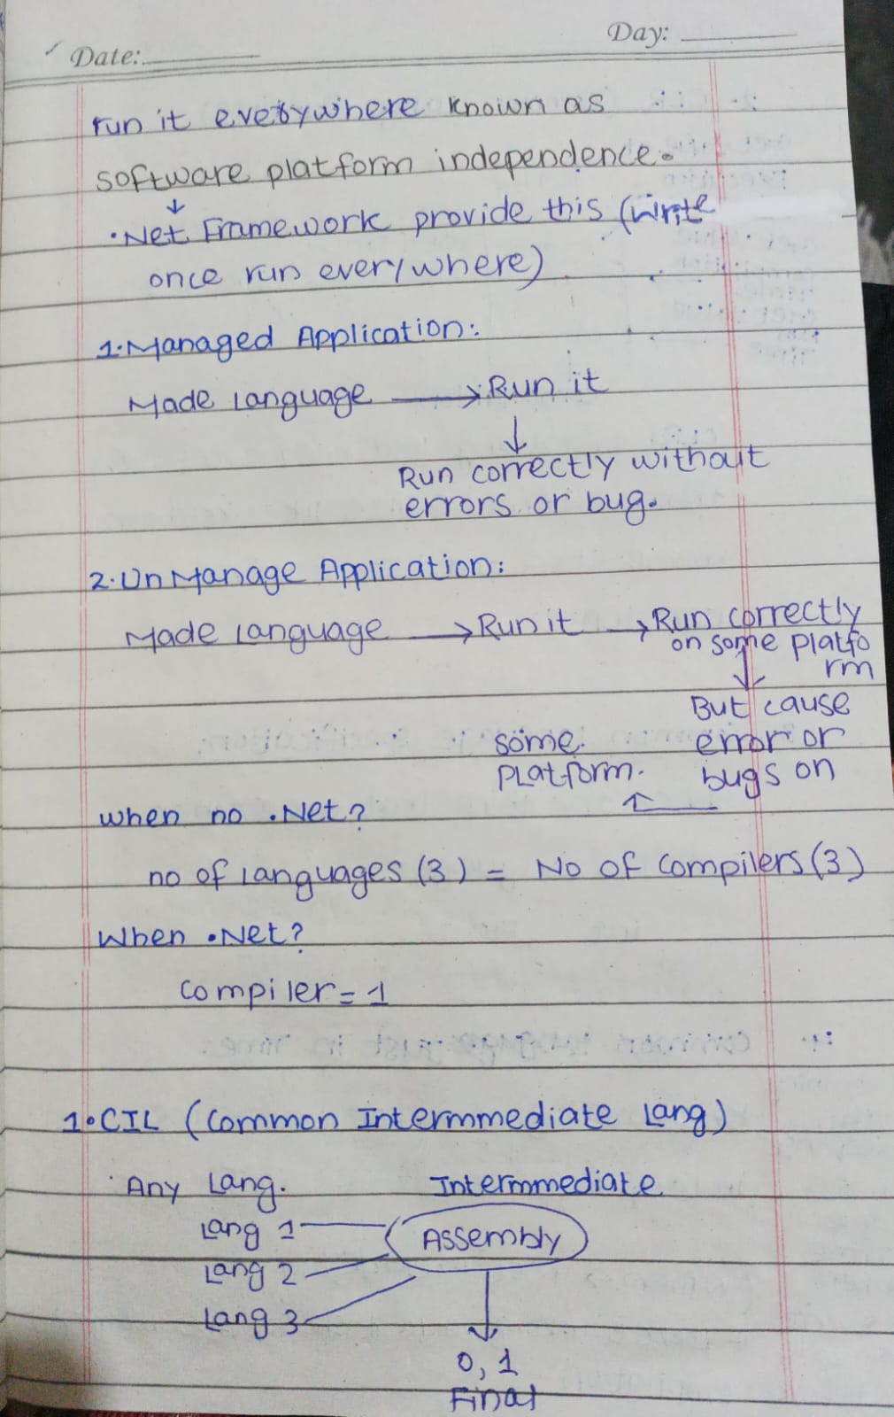
What is .NET Framework?
.Net Framework is a platform that allows us to develop software applications and libraries called “managed applications”.
.NET Framework is a language neutral.
It is not a programming language. Instead, it creates an environment where programs written in different supported languages can run smoothly with the help of libraries and runtime support.
Key Features
- Supports multiple programming languages (C#, VB.NET, J#, etc.)
- Provides a huge library of ready-made code (called Base Class Library)
- Manages memory, security, and program execution automatically
- Allows web, desktop, and mobile apps to be built
Continue…
- .NET is a new framework used to develop web-based and Windows applications inside the Microsoft environment.
- It brings a major change in Microsoft’s strategy because it shifts application development from being client-focused to server-focused. This means more processing and logic happens on the server instead of the user’s device.
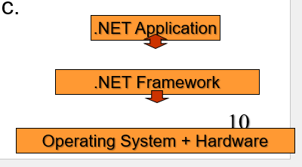
Manages and Unmanaged Applications
Managed application:
Program that runs under the .NET runtime. The runtime manages memory and execution so developer does not handle low-level tasks.
Unmanaged application:
Program that runs directly on the operating system. Developer must manage memory and other resources manually, so it is more likely to cause errors if not handled properly.
Compiler
Software that translates high-level language (C++, Java, C#, etc) to machine language.
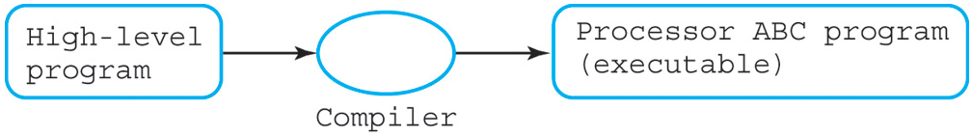
Compiler X can convert high-level Y to machine language Z.
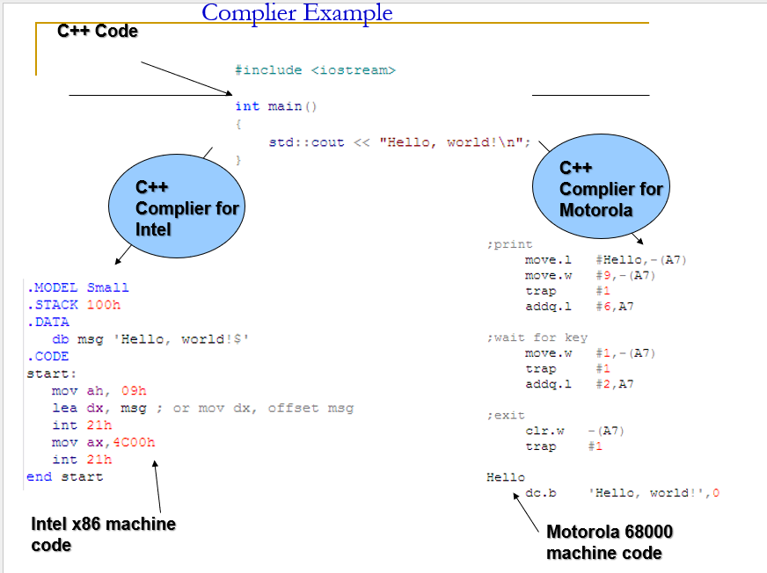
Problem
A big problem for developers is that different devices use different processors to run code. Windows, Mac, Unix computers, mobile phones, and other devices all have different hardware.
One way to make a program work on all these devices is to translate the program into the native instructions of each platform 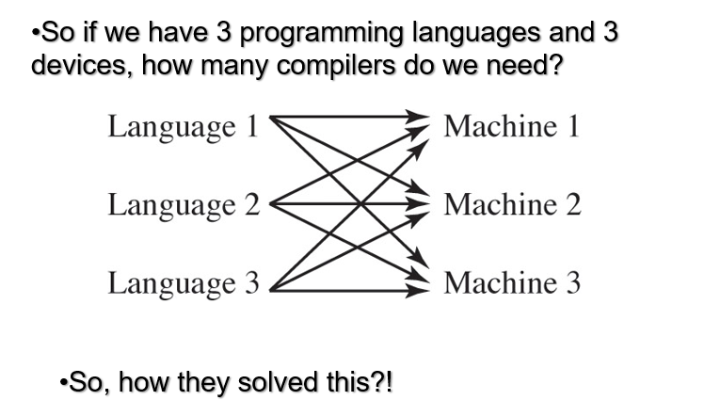Two-Step Compilation Process
Compilation in .NET happens in two simple steps:
Step 1: Compile Time (First Step)
When we write code in languages like C# or C++, the compiler does not directly convert it into machine code.
Instead, it converts our code into a middle language called:
Common Intermediate Language (CIL)
(also called IL – Intermediate Language)
So:
Your Code (C#, C++, etc.)
⬇
Converted into CIL
This CIL code is not specific to any computer. It is universal.

Step 2: Runtime (Second Step)
When you run the program:
- The CLR (Common Language Runtime) takes the CIL code.
- It uses something called a JIT (Just-In-Time) compiler.
- JIT converts the CIL into native machine code for your specific computer.
So:
CIL
⬇
JIT converts it
⬇
Native code (for your device)
Why This Is Useful?
Because of this:
- You write code once.
- It can run on different devices.
- The CLR makes sure it works correctly for each system.
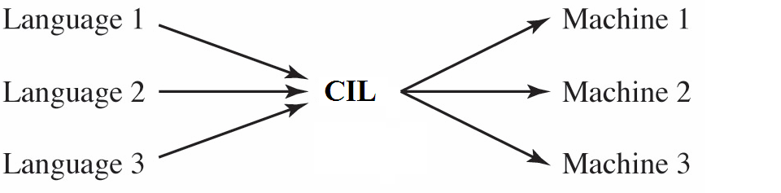
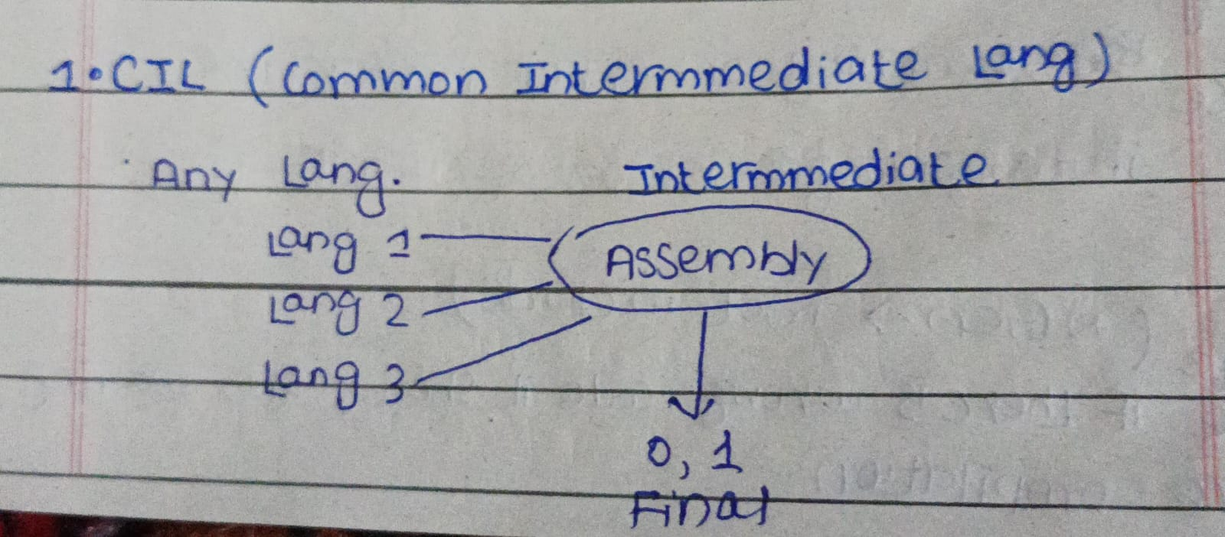
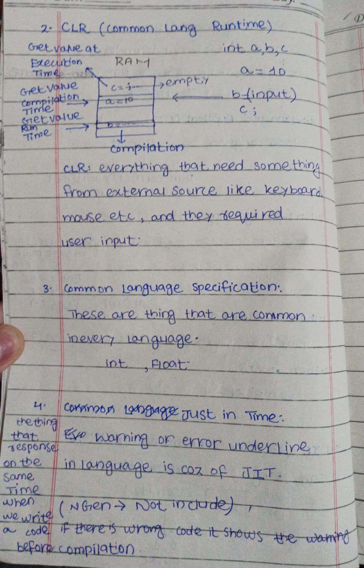
Common Intermediate Language (CIL)
CIL is a middle language used in the .NET Framework.
- It was first called Microsoft Intermediate Language (MSIL).
- It is CPU independent (not made for one specific processor).
- It is platform independent (can work on different systems).
- Any system that supports .NET can run CIL code.
So, CIL is like a common language between your program and the computer.
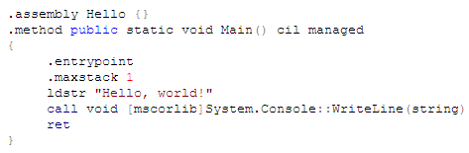
Common Language Runtime (CLR)
What is CLR?
CLR is the execution engine of .NET.
It is responsible for running our program.
It manages:
- Memory
- Security
- Execution of code
How CLR Works
When we run the program:
- The CLR (Common Language Runtime) takes the CIL code.
- It uses something called a JIT (Just-In-Time) compiler.
- JIT converts the CIL into native machine code for our specific computer.
So:
CIL
⬇
JIT converts it
⬇
Native code (for your device)
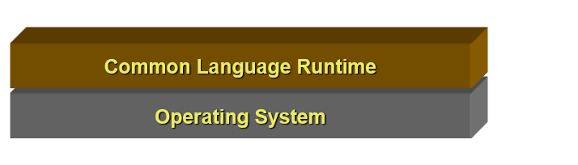
What is NGEN?
Native Image Generator (NGEN) is a tool.
Normally:
- JIT compiles code at runtime.
But NGEN:
Converts CIL into native code before running.
- Creates a native file for a specific system.
- This makes program start faster.
Common Language Specification
CLS is a set of rules that .NET languages must follow so they can work together properly. These are the things that are common in very language like int float etc.
Just in Time
It works at runtime (when program is running).
JIT’s job is:
- To convert CIL (middle language) into machine code
So the computer can execute it
The things that respond at the same time when we write code. If there is wrong code it shows warning before error.
How JIT Works (Simple Steps)
- Method is called for the first time
- JIT compiles its IL into machine code
- Machine code is optimized
- It is executed
- Compiled code is stored (cached)
Next Time the Method is Called
- No need to compile again
- Cached machine code is used
- Execution becomes faster
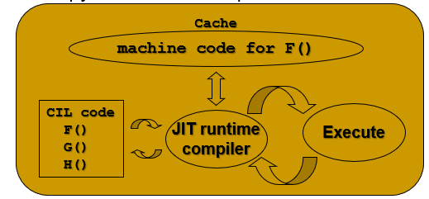
Compilation Process
So if we have 3 programming languages and 3 devices, how many compilers do we need?
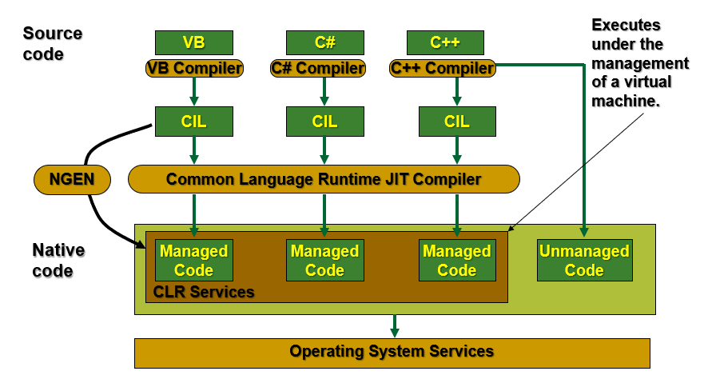
.NET Framework Base Class Library
Object-oriented collection of reusable types
Collections, I/O, Strings, …
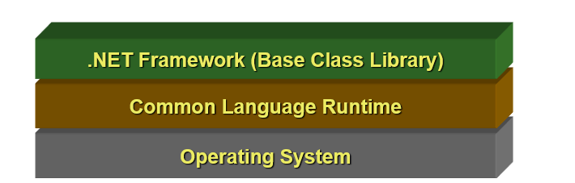
.NET Framework Data Access Layer
It is used to access and manage data from databases.
What It Does
- Access relational databases
- Uses disconnected data model (data is fetched and then stored locally)
- Works with XML data
- Allows reading and writing data
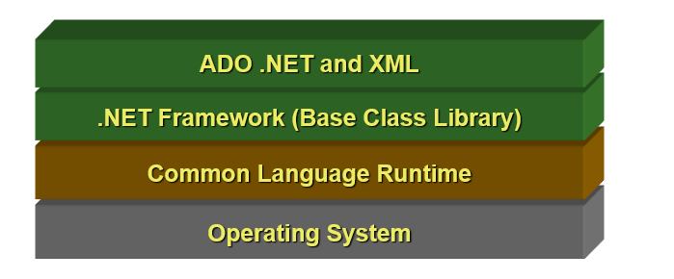
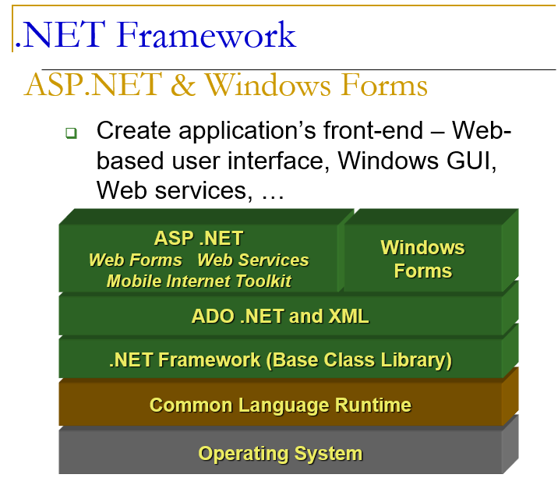
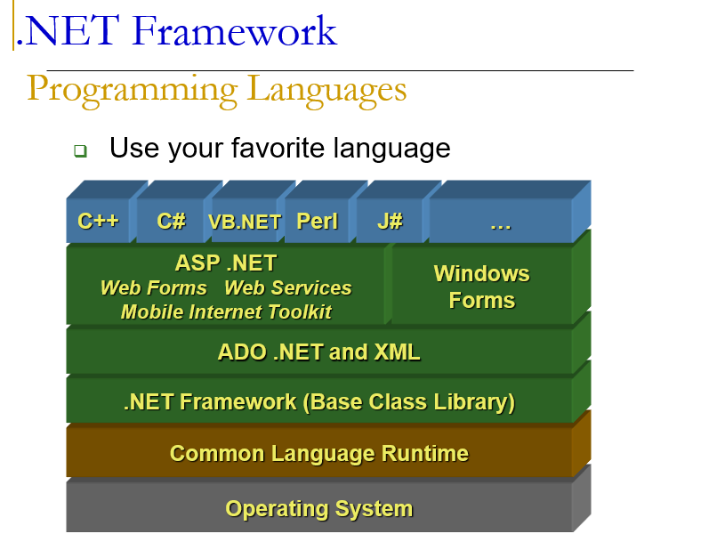
Platform and Language Independent
.NET is platform and language independent because of its design.
How It Works
- Code written in different languages (C#, VB.NET, etc.) is converted into
Common Intermediate Language (CIL).
- CIL is not specific to any language or platform.
- CLR/JIT converts CIL to machine code for that device.
So same CIL code can run on different platforms.
Can We Use Code of One Language in Another?
Yes
- VB.NET and C# code can work together.
- Classes written in VB.NET can be used in C#.
- Classes written in C# can be used in VB.NET.
Native Image Generator – Install Time Compilation
It compiles code when the application is installed (not at runtime).
What It Does
- Converts Common Intermediate Language (CIL) into machine code
- Happens during installation
- Creates a native image
- Speeds up startup time
Advantage
- Program starts faster
- No need for runtime JIT compilation
Limitation
- Cannot do heavy optimizations like JIT
- Original IL must still exist for type information
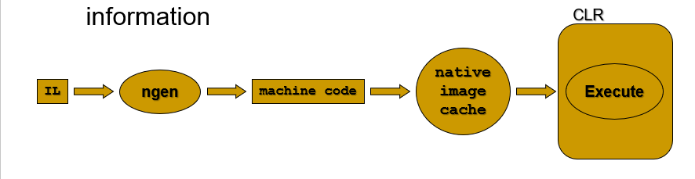
What are primitive Datatypes?
Primitive data types are the ones that were included into the language from the very beginning, when the language was first created. They form the foundation for all other data types.
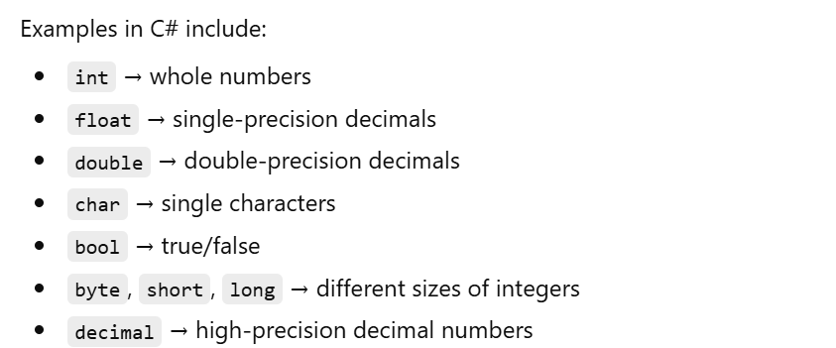
Variables and Identifiers
A variable is a named storage location in memory. Rules for naming:
- Must start with a letter or underscore (_)
- Can contain letters, digits (0-9), and underscores
- Cannot use C# reserved keywords (like int, class, if)
- C# is case-sensitive: myAge and myage are different!
Arithmetic Operators
Used to perform mathematical calculations
Examples: addition, subtraction, multiplication, division, remainder
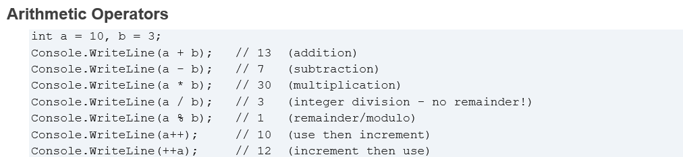
Logical Operators
- Used to perform logical (true/false) operations
- Used with boolean values
- Helps in decision-making conditions
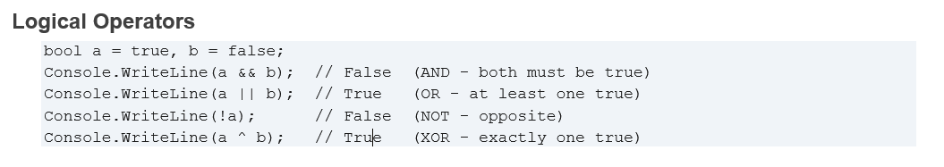
Comparison Operators (Relational Operators)
- Used to compare two values
- Always returns true or false
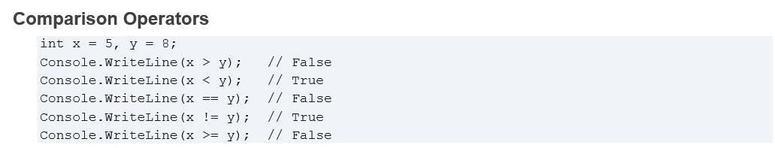
What is Operator Overloading
Operator overloading means redefining or changing the functionality of an operator for user-defined types.
- Normally operators work with built-in types
- With overloading, they also work with user define datatypes.
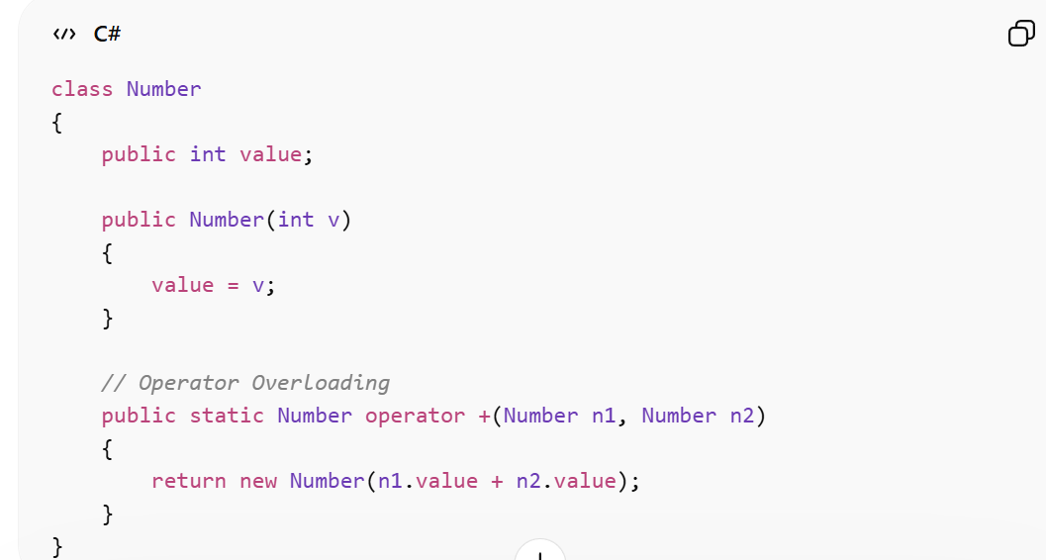
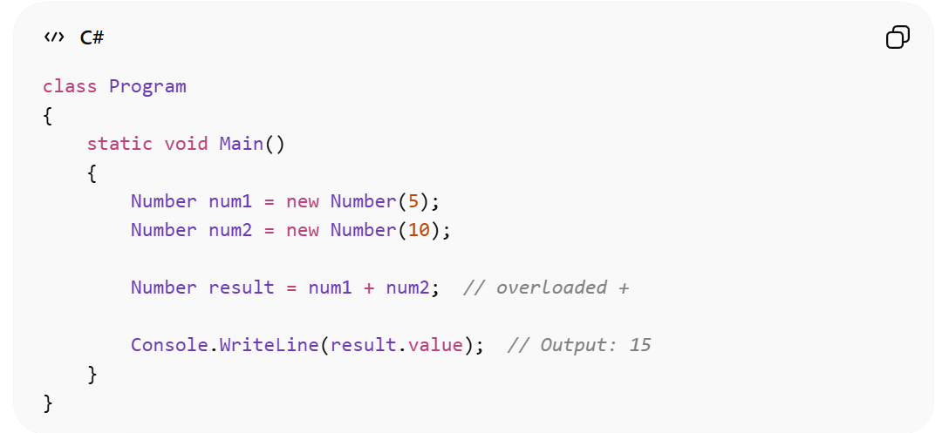
Structure: Combinations of multiple datatype
Expression: Code that calculates something and gives a result.
Enumerated Types
An enumerated type (enum) in C# is used to define a group of related constant values. We use it when we want user to given a leverage and also want to bound it. It makes code more readable and organized.
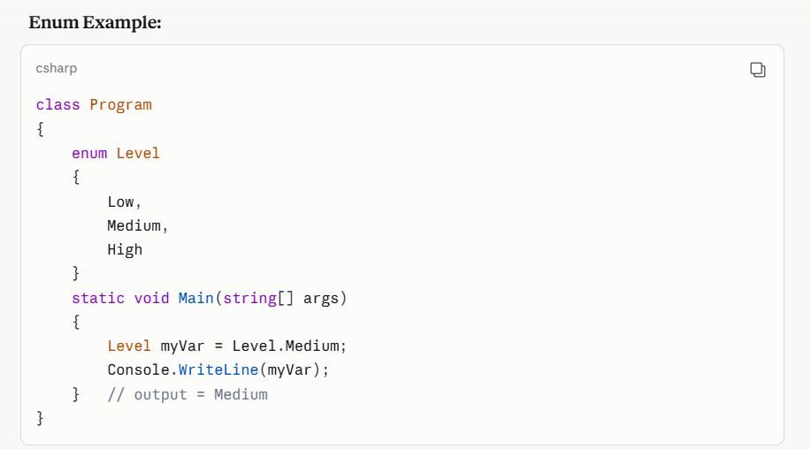
Structure in C# (struct)
- A structure (struct) in C# is a value type used to group related variables under one name.
- It is similar to a class but is used for small and simple data objects.
- Stored in stack memory (unlike class which uses heap).
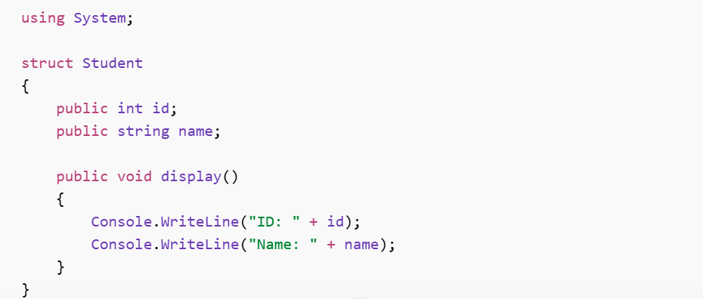
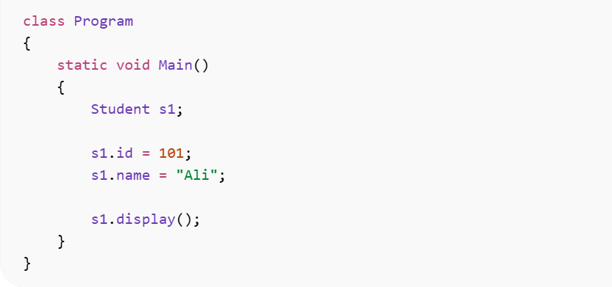
Strings:
Definition: A string is a combination of multiple Data types and is used to store a sequence of characters.
Points:
- It is a reference type.
- Strings are immutable.
- Supports multiple built-in methods.
Arrays in C#
An array in C# is a collection of items of the same type stored in a single variable.

Why Arrays?
1. Variables Are Non-Contiguous
- Normal variables are stored separately in memory, not together.
2. Variables Have No Relation
- Each variable is independent.
- The program doesn’t know that a, b, c are related.
3. No Knowledge of Distance Between Variables
- Variables don’t know how far other variables are in memory
To Overcome this
- Arrays store all elements in contiguous memory.
- They group related data together.
- Elements can be accessed using an index.
- Easy to loop through and process multiple values.
Objectives of Arrays in C#
1. Provide Sequence (Ordering & Positioning)
- Arrays store elements in a specific order.
- Each element has a position called an index starting from 0.
2. Efficient Memory Usage
- Arrays take a single block of memory and divide it into partitions for each element.

Array Vs List
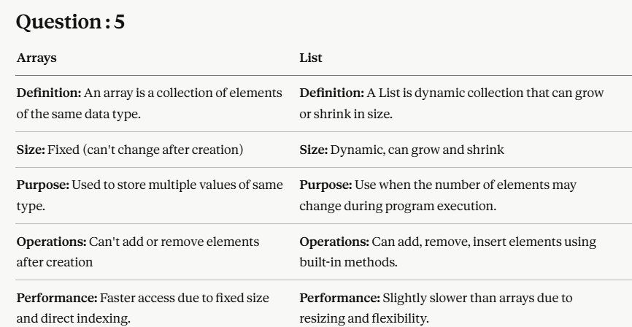
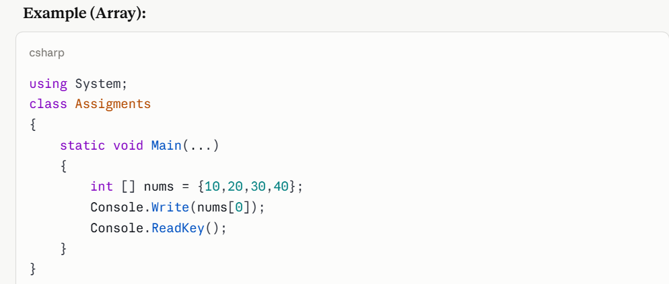
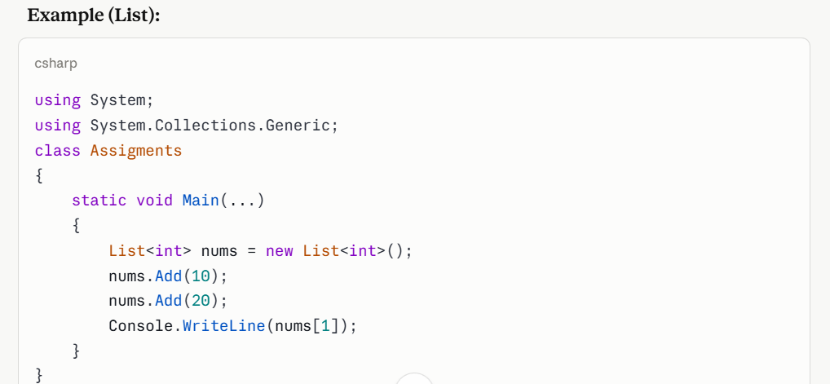

Key Points
1. Minimum Size of Array
- Allowed = 1;
- Recommended = 2
2. Instantiation in C#
Instantiation means creating an object or a variable of a class, struct, or array in memory so it can be used.
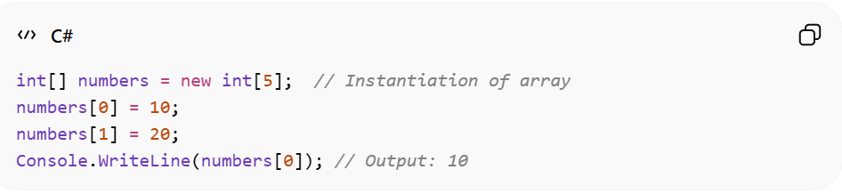
Values Types vs Reference Types
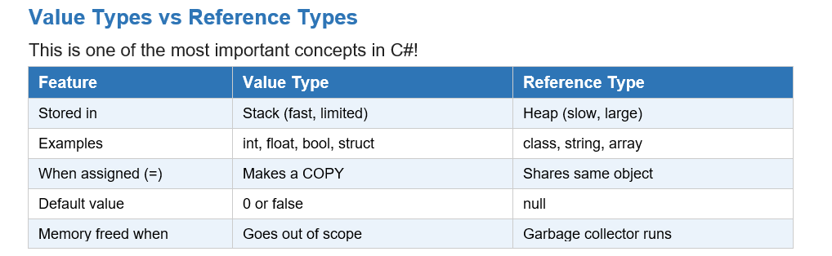
2D Array vs Jagged Array
2D Array
A 2D array is a fixed grid (like a table) where every row has the same number of columns.

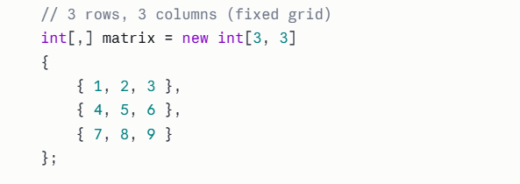
Jagged Array
A Jagged Array is an array of arrays where each row can have a different number of columns.
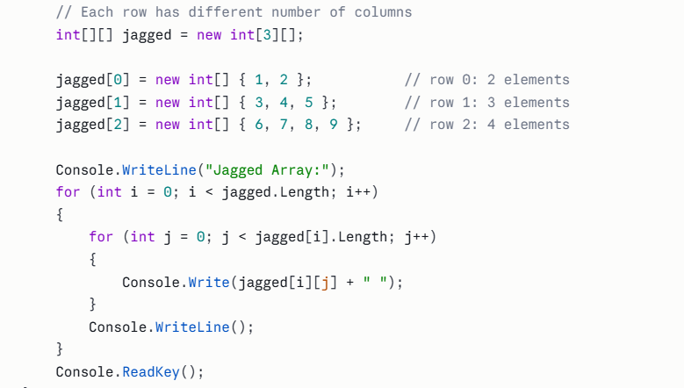
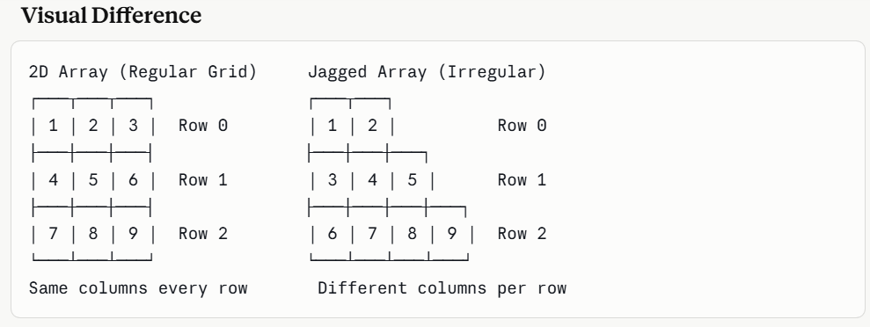
Classes
It acts like a blueprint or template for objects. It defines the properties and functionality of an object.
For What Things Classes Can Be Made in C#?
Classes can be made for any real-world physical entity that has properties (data) and behaviors (functions).
How many functionalities and properties required for entity to be a class?
- Minimum two Functionalities
- Minimum one attribute
Why Classes?
- Classes help represent real-world things in programming.
- Group related objects together
Object
- Object is a medium to interact with class
- Object has no information of code
Can an Object Be Made Inside Its Own Class?
Yes, it is possible, but usually it is not needed.
Reason:
An object is used to access the members of a class from outside the class.
When we are inside the class, we can directly access its variables and methods without creating an object.

Static Members
Static members are variables or methods that belong to the class itself, not to objects.
- They are shared by all objects of the class.
- They can be accessed without creating an object.
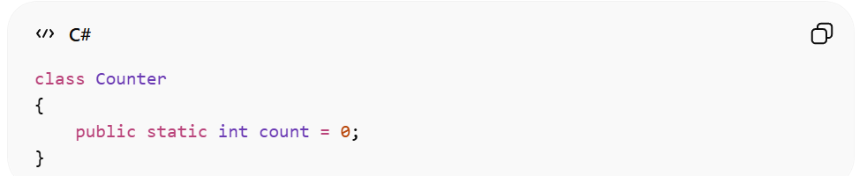

Static Methods
A static method is a method that belongs to the class and can be called without creating an object.
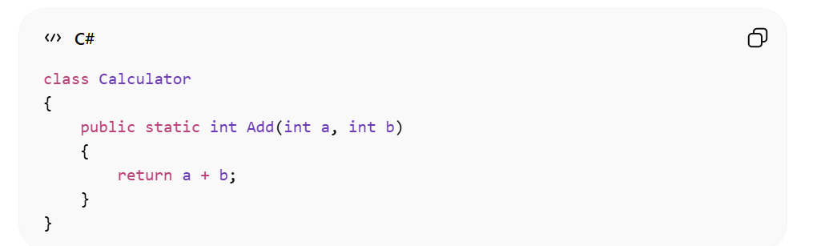
Constructor in C#
A constructor is a special method in a class that is automatically called when an object is created.
It is mainly used to initialize (assign values to) the object’s data members.

Key Points
- Constructor name is same as the class name.
- It does not have a return type (not even void).
- It is called automatically when an object is created.
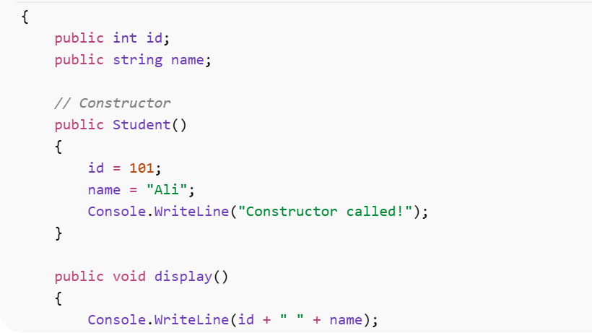
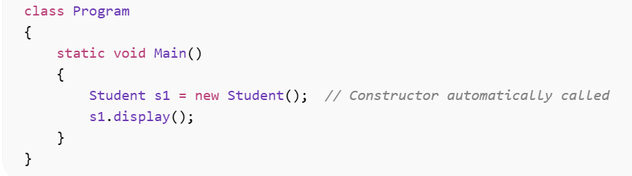
Destructor in C#
A destructor is a special method that is automatically called when an object is destroyed.
It is used to release resources or clean up memory.

Key Points
- Destructor name is same as class name but with ~ (tilde).
- It cannot have parameters.
- It cannot be overloaded.
Note:
- Destructor has no link with the provoking of constructor and when compiler leave class it executed destructor only one time.
- Destructor can only be made when its constructor exist.
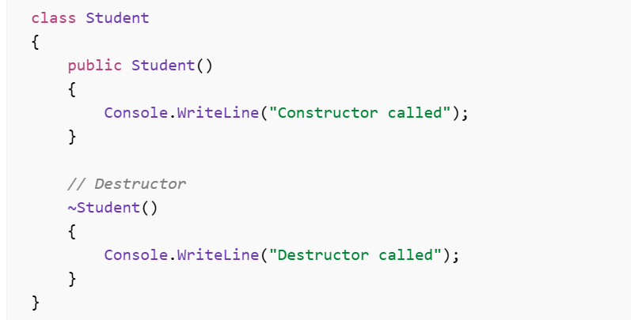
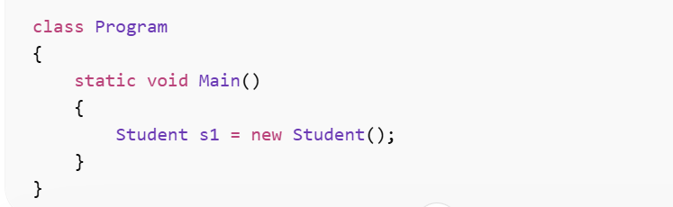

What is inheritance?
Inheritance is an OOP concept in which one class acquires the properties and methods of another class.
Inheritance = Reusing the features of an existing class.
Why Inheritance?
We use inheritance when some functionalities are similar between entities, and some are different.
- Similar functionalities: put in the parent class
- Different functionalities: put in the child class
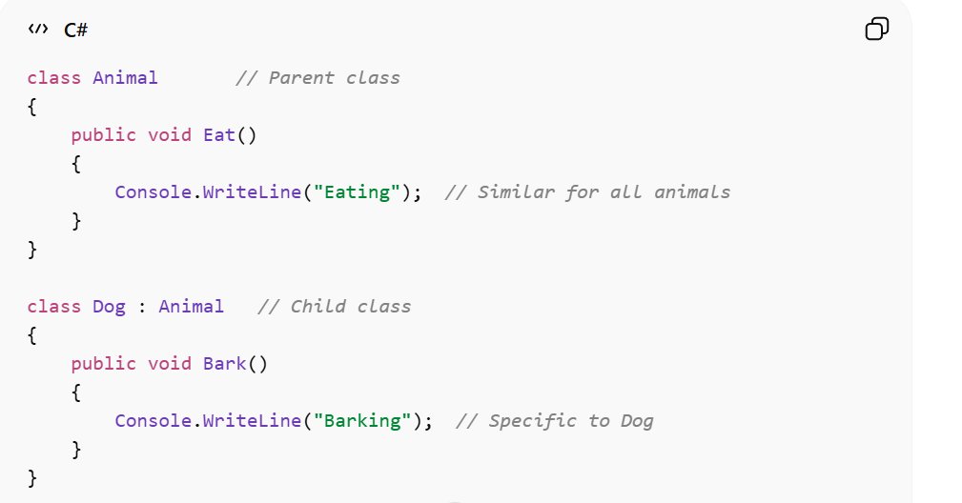
Types of Inheritance in C#
1. Single Inheritance
- One child inherits from one parent.
- Maximum Classes: 2
- Minimum Classes: 2
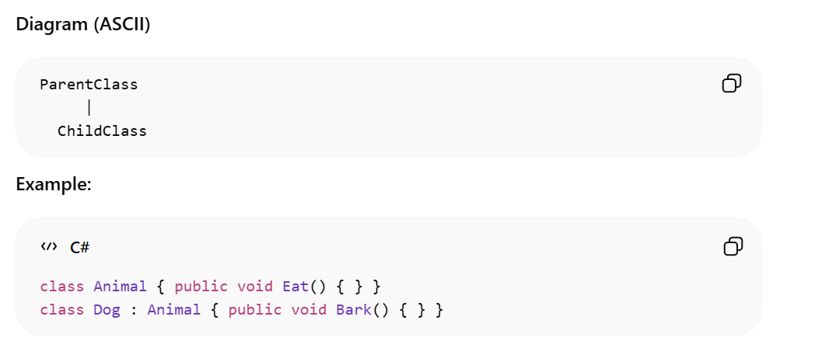
2. Multilevel Inheritance
- A chain of inheritance: Child inherits from parent, and grandchild inherits from child.
- Minimum Classes: 3
- Maximum Classes: can be more than 3
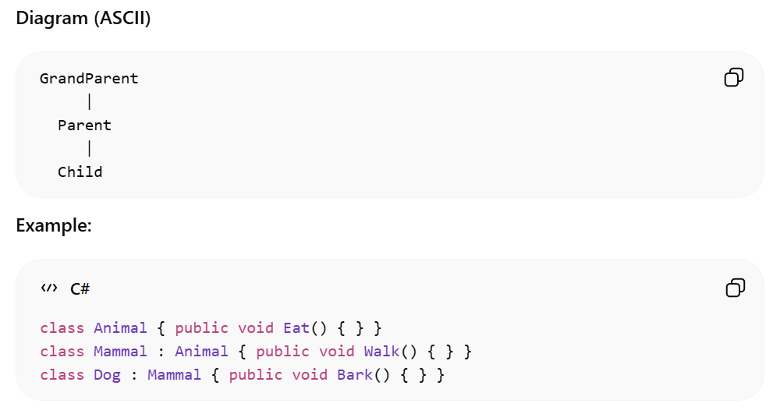

3. Multiple Inheritance
Multiple inheritance is when one child class inherits from more than one parent class.
Problem in C#: C# does NOT allow multiple inheritance with classes to avoid ambiguity (like the “diamond problem”).
Instead, C# achieves multiple inheritance using interfaces.
4. Hybrid Inheritance in C#
Hybrid inheritance is a combination of two or more types of inheritance (single, multilevel, hierarchical).
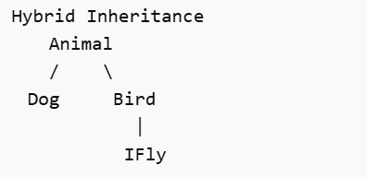
Function Overloading
- Function with same name but with different number parameters
- It is done in the same class
- It is used to perform similar tasks in different ways
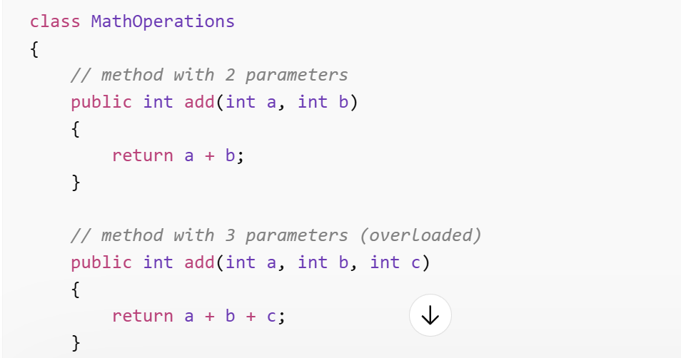
Function Overriding
- Function overriding means function having same name and same parameters in parent and child class
- It is used in inheritance
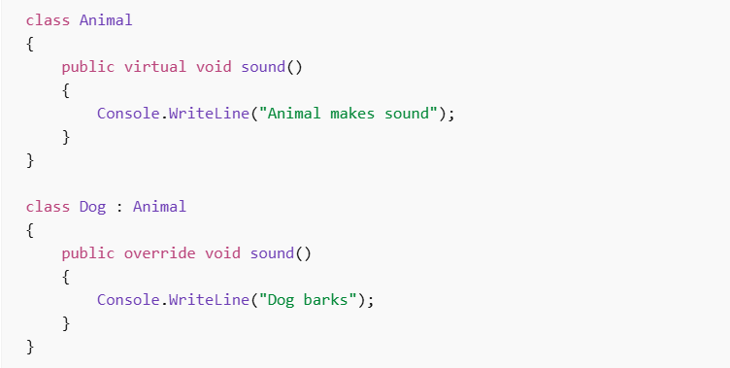
What are Exceptions?
An exception is an error that happens while your program is running. Instead of crashing completely, C# lets you CATCH the error and handle it gracefully.
Three Common runtime errors:
1. DivideByZeroException:
This error happens when we try to divide a number by 0. In math, division by zero is not allowed, so program crashes.
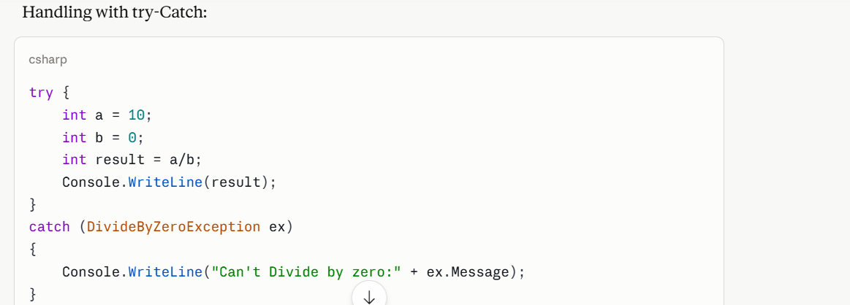
2. Format Exception:
This happen when the input format is wrong. For example, converting a string to a number when string is not numeric.
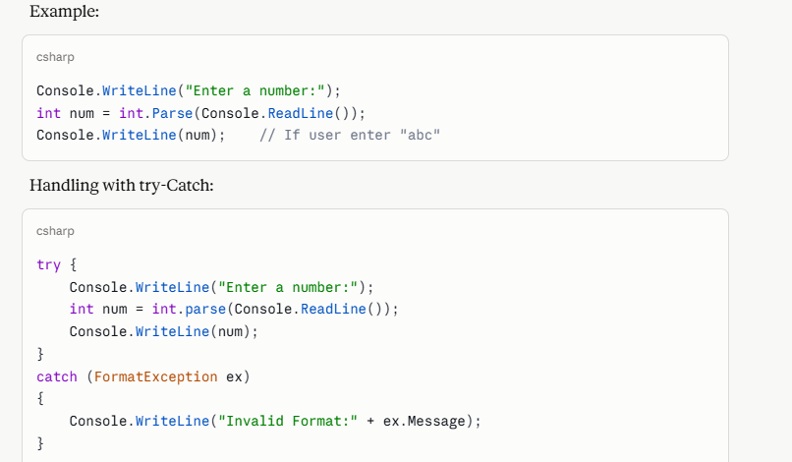
3. IndexOutOfRangeException:
An index out of range exception happens when we try to access an array using an index that does't exist.
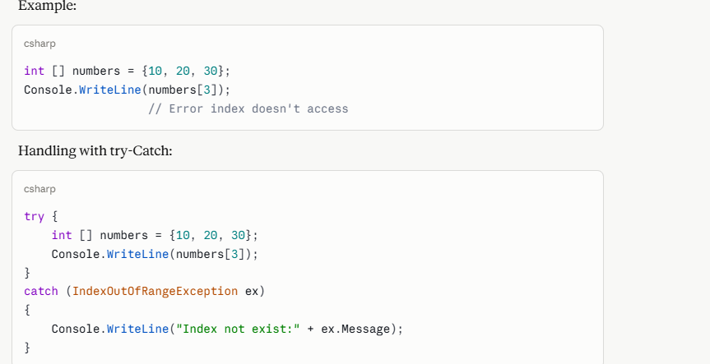
Error vs Warning vs Exception
Error
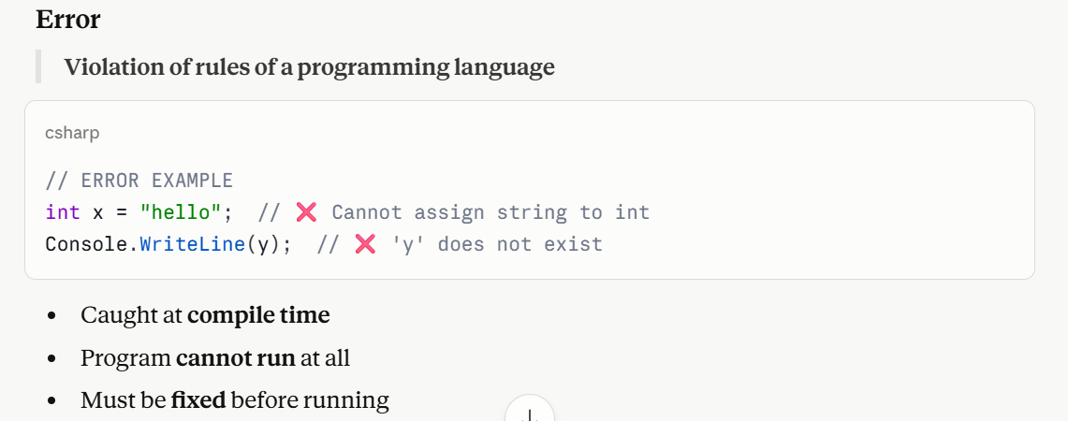
Warning
A message from the compiler indicating a potential issue that doesn't stop the program from running but might cause bugs or unexpected behavior later.
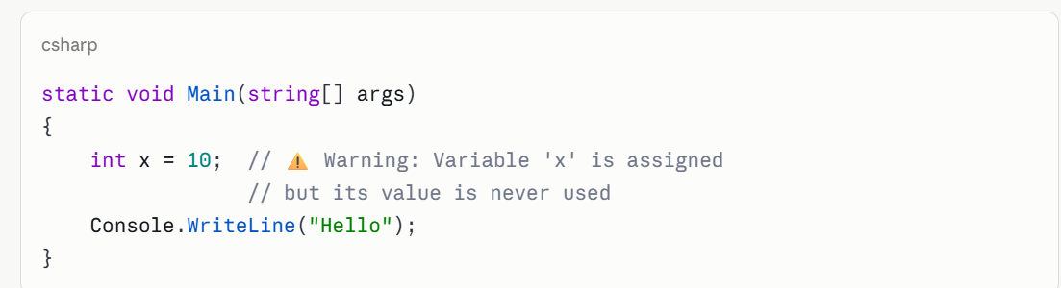
Exception
Unexpected error at runtime due to unexpected input or situation.
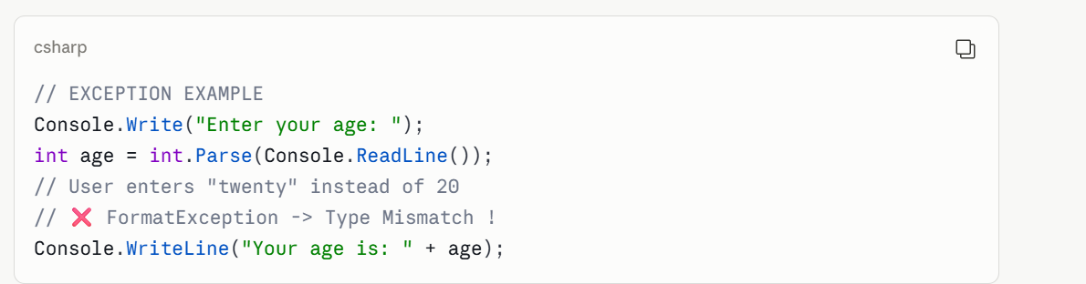
Lecture 11
Introduction to WPF
1. What is WPF?
WPF stands for Windows Presentation Foundation. It is a modern toolkit that helps developers build good-looking and interactive apps on Windows.
- It is a completely new way to show graphics (visuals) on Windows.
- It supports rich-media apps that have images, videos, and animations.
- It keeps the visual design (UI) separate from the code logic using a language called XAML.
- It was inspired by web technologies like HTML, CSS, and Flash.
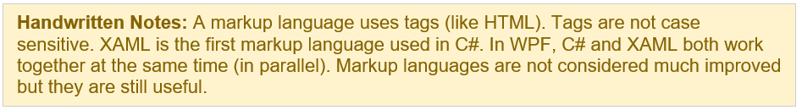
2. Key Features of WPF
2.1 Vector Graphics
- WPF draws shapes (lines, curves) instead of tiny dots (pixels).
- Uses GPU → smooth and sharp graphics.
- Looks clear on any screen size or zoom.
- Supports rich colors with transparency.
2.2 Audio and Video Support
- Can play sound and video inside the app.
- Supports formats like WMV, MPEG, AVI.
2.3 Animation
- Easy to add movement (no complex code).
- Uses time-based animations.
- Can start on actions like button click.
- Can be written in XAML.
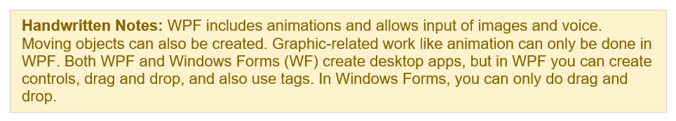
2.4 Styles and Templates
- Like CSS → control how UI looks.
- Apply same design to many elements.
- UI can change on actions (e.g., hover).
Templates types:
- ControlTemplate → change control design
- ItemsPanelTemplate → change item layout
- DataTemplate → show data style
- HierarchicalDataTemplate → for tree data
2.5 Rich Text
- Smooth and clear text (ClearType).
- Supports many languages (Urdu, English).
- Fast display using video memory.
- Looks good on all screen sizes.
2.6 Commands
- Predefined actions like Copy, Paste, Save.
- Less repetitive code.
- Connect UI and logic easily.
2.7 Object-Based Drawing
- Draw using shapes (line, rectangle, etc.).
- No need to handle pixels manually.
- WPF manages drawing efficiently.
- Shapes can be used inside UI controls.
3. WPF vs Other Technologies
3.1 WPF vs Windows Forms (WF)
Windows Forms is the older way to build Windows apps. Here is a simple comparison:

Windows Forms (WF) | WPF
Older, more tested technology | Modern and more powerful
UI and code are mixed together | UI (XAML) and code (C#) are kept separate
Basic graphics only | Advanced graphics, animation, rich media
Only drag and drop | Drag and drop + tag support + more controls

3.2 WPF and DirectX
- WPF works on DirectX behind the scenes.
- So even simple apps look smooth and modern (no rough edges).
- Graphics stay clear when you zoom in or out (no blur).
3.3 Silverlight
Silverlight was a browser plugin that brought WPF technology to the web.
It used the same XAML language as WPF.
It was more limited than WPF but worked across different browsers.
4. XAML — The Design Language of WPF
4.1 What is XAML?
- XAML stands for eXtensible Application Markup Language. It is the language used in WPF to describe what the user interface looks like.
- It is an XML-based language — it uses tags just like HTML.
- It is declarative: you say WHAT you want, not HOW to do it.
- Example: You say 'I want a button here' — you do not draw it pixel by pixel.
- It keeps the visual design separate from the programming logic.
- Designers can work on XAML in Blend while developers work on C# in Visual Studio — at the same time!
- XAML has a tree structure — UI elements are nested inside each other like boxes.
4.2 XAML vs HTML + CSS
If you know web development, this comparison will help:
- HTML describes a web page's structure; XAML describes a WPF app's structure.
- CSS styles web pages; WPF Styles style app controls.
- XAML is generally more powerful than HTML for desktop apps
5. XAML Elements and Attributes
In XAML, every part of the UI is written as an XML element. Here is how it works:
- Writing an XML element (e.g., <Button>) = creating a new object in code.
- Setting an attribute (e.g., Width=200) = setting a property in code.
- All UI elements share common properties: Width, Height, Cursor, Tag, etc.
XAML Basics- Example
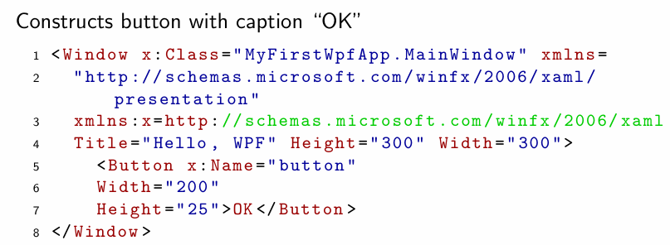
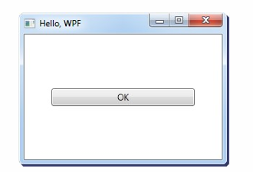
Grid: Do logical Portioning
X: Whenever we use new tag, we use x to access its properties
What does this code mean?
- <Window> is the root element — the main container of the app.
- The xmlns lines are like 'import' statements — they bring in WPF and XAML libraries.
- Title, Height, Width are properties of the window.
- <Button> creates a button with the label 'OK', width 200 and height 25.
6. Property Elements (Complex Properties)
Sometimes a property needs a full object instead of a simple text value. XAML handles this with Property Elements.
Example — Rotating an ellipse by 45 degrees:
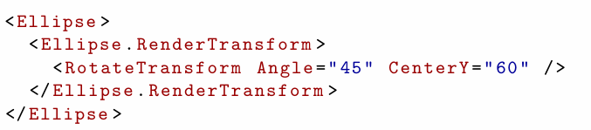

- The ellipse has a property called RenderTransform (how it is visually changed).
- We set that property to a RotateTransform object with a 45-degree angle.
- The format is: TypeName.PropertyName — e.g., Ellipse.RenderTransform.
7. XAML vs Code-Behind
In WPF, you can create UI elements in two ways: with XAML or with C# code. Both produce the same result, but XAML is always preferred.
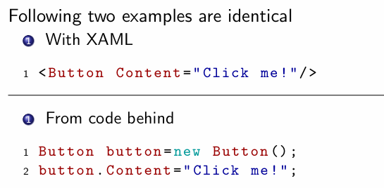
Lecture 12
WPF Layout Containers
What is a Container?
A container is an element that holds other elements. Or in other words To add some controls we need something called containers (as they itself have no body/canvas).
Key Points:
- In HTML, divs and spans serve as containers
- Every container is given a space to consume
- All children live within that space
- WPF containers are called Panels
Types of Containers
- StackPanel,
- DockPanel,
- WrapPanel
These are elements are arranged in a stacking order i.e. first come goes in the beginning
Canvas Container (Absolute Positioning)
The Canvas is an absolute-coordinate layout container. Each child is positioned using fixed Left/Top values via attached properties.
- It’s an element that holds other elements
- It simply positions each item using fixed coordinates
- Places elements behind or in front of others (depending on the z-order)
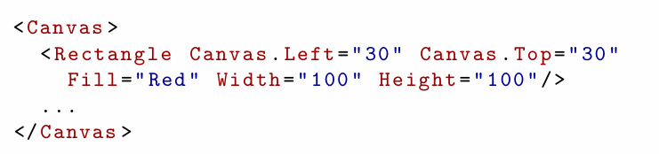
Second Definition
Background on which we draw something like shapes (squares, rectangles etc) is known as Canva.

Key Points
When there is a canvas present inside another canvas then the inside canvas can’t be greater than outer canvas because it violates the property of Containership.
Value of Z-Index: Can’t be 0 it starts from 1 up to whatever we choose.
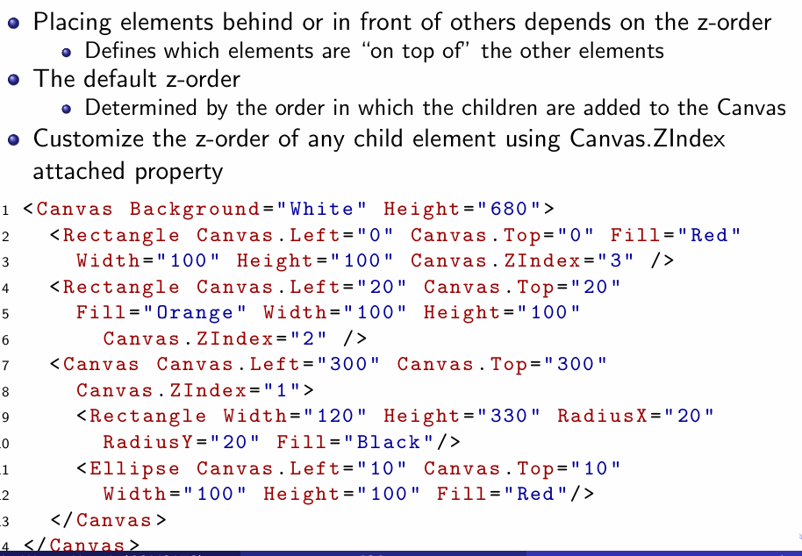
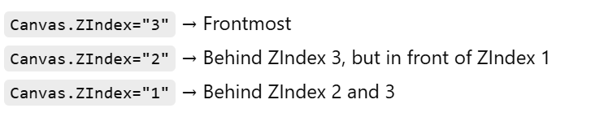

StackPanel
A StackPanel arranges controls in a single row or a single column.
The arrangement depends on the Orientation property.
The Orientation can be:
- Vertical → controls are placed one below another.
- Horizontal → controls are placed side by side.
If the width or height of the child elements is not explicitly specified, the controls are automatically sized by the StackPanel.
It is commonly used when you want a simple layout with elements flowing in one direction.
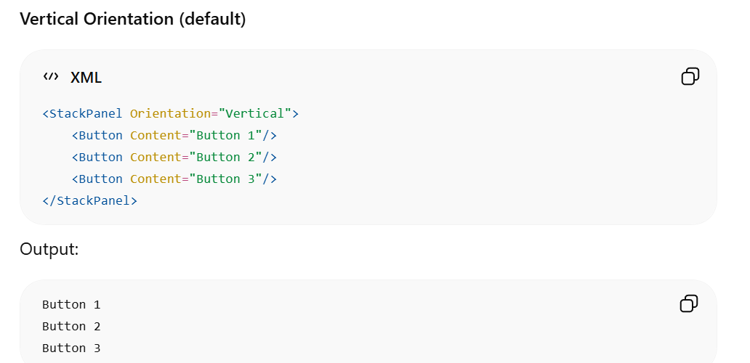
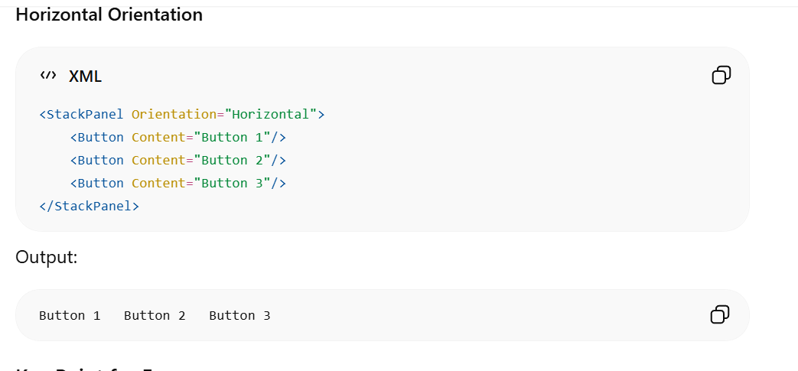
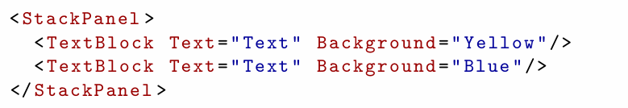
Note: In above image if we don’t use stack panel and keep height equal (left, right, top and Bottom) then textblock will overlap but if we use stack panel then even with the same text block will not overlap so we can also say that stack panel is used to avoid overlapping between controls.
WrapPanel
- A WrapPanel is similar to a StackPanel.
- It arranges controls in a single row or column based on the Orientation property.
- When there is no more available space, the controls automatically move (wrap) to the next row or column.
- This makes it useful when the number of elements is unknown or the window size may change.

Orientation
- Horizontal → Elements are placed left to right. When space runs out, they move to the next row.
- Vertical → Elements are placed top to bottom. When space runs out, they move to the next column.
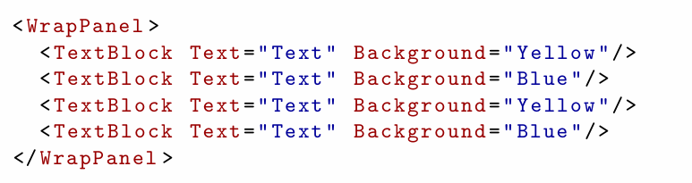
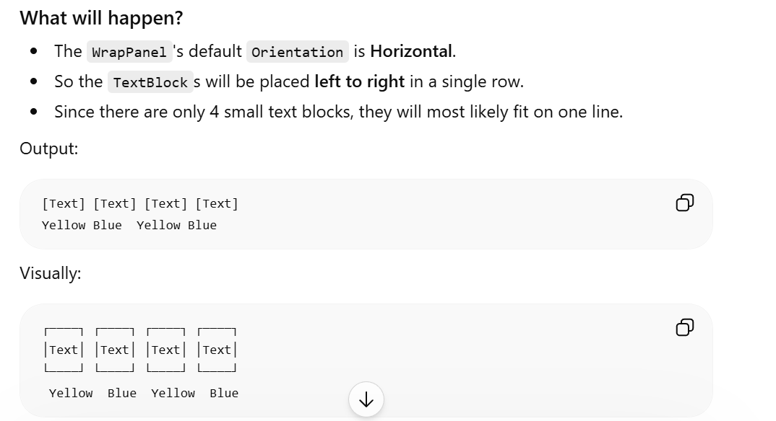
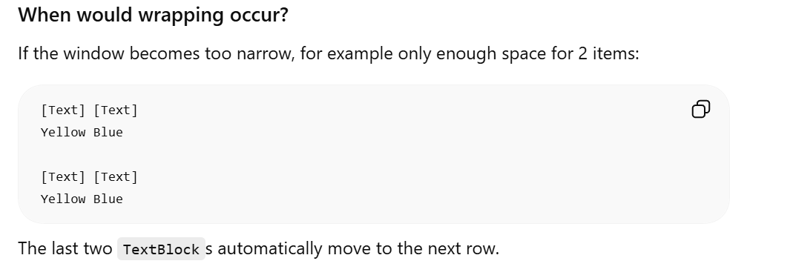
Note: It is mostly used for text related properties.
DockPanel
We use a DockPanel when we want to arrange controls around all four sides of a window or panel (Top, Bottom, Left, and Right).
To dock an element to the center of the panel, it must be the last child of the panel LastChildFill property must be set to true.
If LastChildFill="True", the last control automatically fills the remaining empty space in the center.
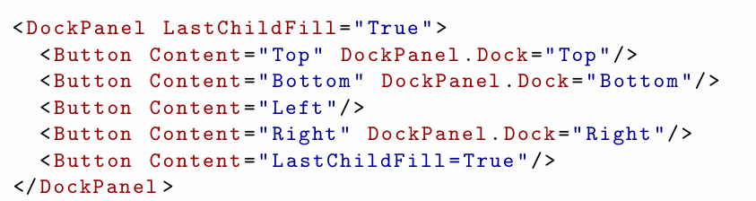

Grid Panel
A Grid is the most powerful layout container in WPF.
It arranges controls in a table-like structure using rows and columns.
Key Points
A Grid divides the window into rows and columns.
Used for logical Partioning.
You decide how many rows and columns you want.
Each control is placed in a specific row and column.
The position is set using:
- Grid.Row
- Grid.Column
Almost any layout can be created using a Grid.
However, for simple layouts, StackPanel is often easier.
Grid Panel Continue…
Number of rows is defined by a content property called ”RowDefinitions”
- Each row can be set a height
It is the same with ”ColumnDefinitions”
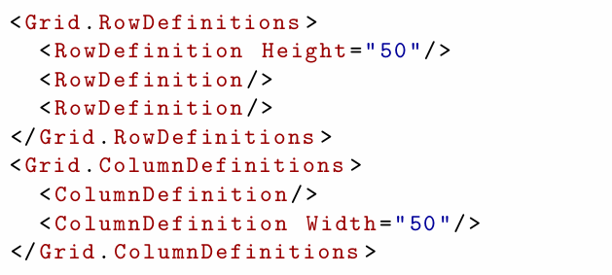
Grid with Row and Column Definitions
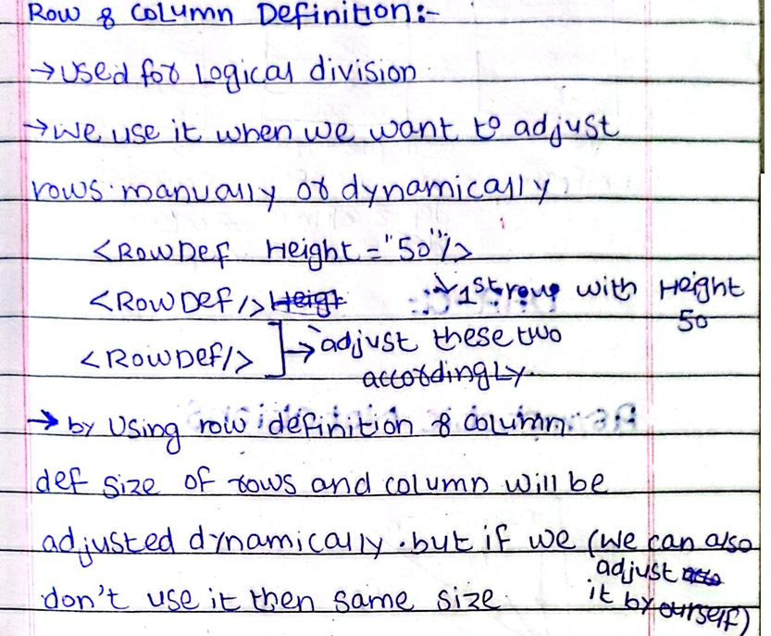
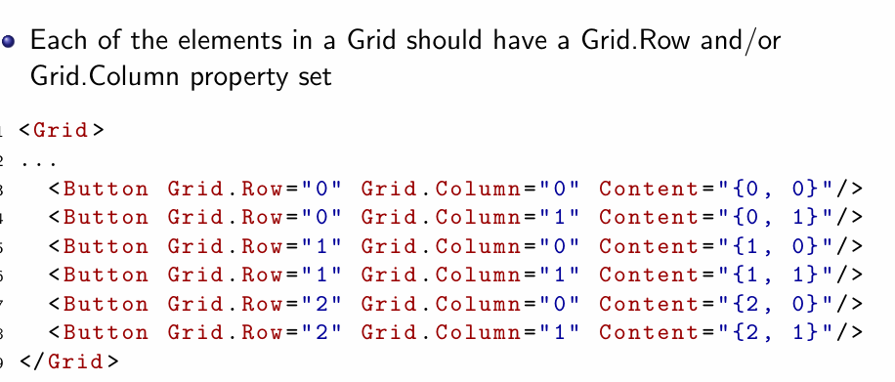
UniformGrid Panel
A UniformGrid is similar to a Grid, but it is simpler.
Key Points
- It arranges controls in rows and columns.
- All controls have the same size (same width and height).
- You cannot specify the exact position of a control using Grid.Row and Grid.Column.
- The UniformGrid automatically places controls in the available cells.
- The number of rows and columns determines how the controls are arranged.
- The FlowDirection property controls the order in which controls are placed (e.g., LeftToRight or RightToLeft).

